CROWN CARTS
(352) 399-2804
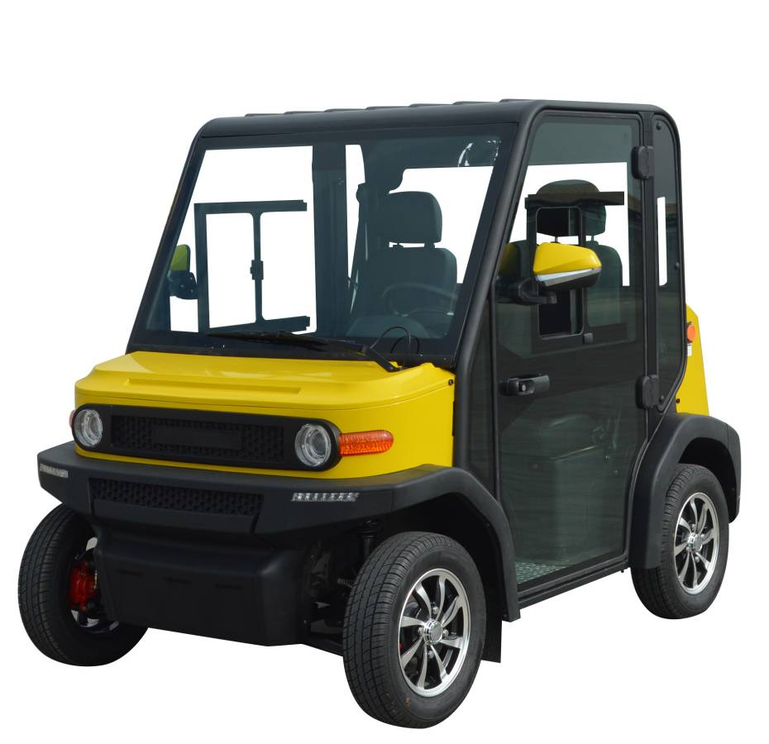
945 Walker Road Wildwood, Florida 34785

The Perfect Solution for the Community Lifestyle!
The Crown View Electric Series Golf Cart is designed
With proven Toyota Technology and delivers not
Only performance but all the feature comforts of
A car. with so many factory included options and
A competitive price, the Crown View is the answer
To your daily neighborhood lifestyle needs!

Included Features
- Air Conditioning with 3 Speed Control & Temperature Control
- Heating System with 3 Speed Control & Temperature Control
- Premium Street Tire & 12” Mag Wheels
- Reverse Gear Audio Safety Alarm
- Intelligent On-Board Charging System
- DOT Safety Rated Windshield
- Windshield Wiper System
- Speed Instrument Panel
- Locking Rear Trunk Storage Space
- Ergonomic Fixed Seating
- DOT Rated 2 Passenger Safety Belts
- Simulated Burled Wood Dashboard
- Premium Stereo System MPS/AUX FM SD Card
- Adjustable Car Style Rear Side View Mirrors
- High Visibility Headlights – Taillights
- Steering Colum Mounted Controls
- 12 Volt in Dash Accessory Charging Port
- Dimensions Length 7FT.1 Inch Width 5FT 7 Inch Hight 5 FT 5 Inch
Colors Available Red, White,, Ocean Blue, Yellow, Neon Green & Maroon
WWW.CROWNCARTS.COM
$12,995 With GEL 60-Volt OR $15,499 Lithium Power Add $995 For Golf Package Upgrade

